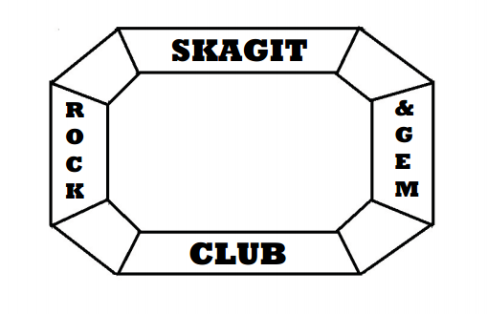
Skagit Rock & Gem Club
P.O. Box 244, Mount Vernon, WA 98274
skagitrockandgem.com
skagitrockandgem@gmail.com

Skagit Rock & Gem Club
Memorial Scholarship
2025 Scholarship Application

We are happy to announce the Skagit Rock & Gem Club Memorial Scholarship in the amount of $1000 for the 2025 Western Washington University (WWU) school year.
The deadline for submitting completed applications is May 15, 2025. Money will be disbursed in WWU Fall quarter 2025.
Applicant Eligibility Requirements:
- Student must be actively enrolled in WWU accredited Earth Science or Geology program.
- Student must maintain a 2.5 GPA or greater and exhibit behavior becoming to collegiate standards. Failure to achieve these conditions will result in a return of all scholarship monies disbursed from our scholarship program.
- Applications must be accompanied by a transcript of current grades and two letters of recommendations prepared by staff WWU professors.
- Student must show active participation in community service of their choice and attach a letter of recommendation by their community service leader.
Name:
Address:
Phone: Email:
High School: GPA:
Current WWU GPA: WWU Student #:
In a one-two page essay please include the following.
- Current and extracurricular activities related to earth science and or geology.
- Your educational and professional goals as they relate to earth science and or geology,
- Information regarding your need for scholarship funds.
Applications can be sent to skagitrockandgem@gmail.com or mailed to Skagit Rock & Gem Club Scholarship Committee; P.O. Box 244, Mount Vernon, WA 98273
Applications must be received or postmarked by May 15, 2025.
Questions? Feel free to email us at skagitrockandgem@gmail.com

